Abigail Merzel
Ms. Sanders
ENG 3416-0002
28 January 2023

An Open Letter to Politicians in the United States
Dear lawmakers,
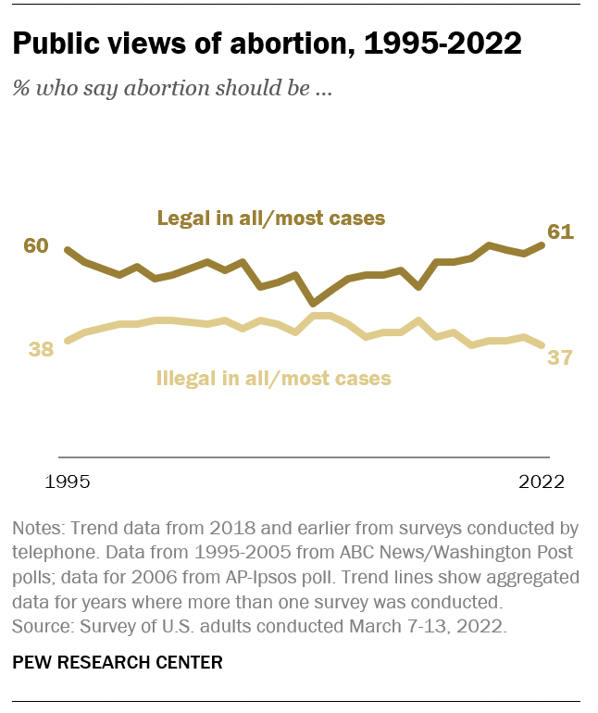
Let’s talk about abortion. When 61% of Americans support abortion rights (Pew Research), why do you continuously make laws preventing it? When only 27% of Congress is made up of women (Pew Research), why is it that the laws regarding abortion are determined by men who will never experience pregnancy? When HIPPA is a part of the law of this land, why is it that lawmakers get to be a part of the conversation about abortion between a woman and her doctor?

First, we should evaluate what an abortion is and what the procedure entails. According to Harvard Medical School, an abortion is the termination of a pregnancy by removing pregnancy tissue, products of conception, or the fetus and the placenta from the uterus. There are many common misconceptions about abortions, and these false facts are often spread throughout the media and by politicians. “Public views of abortion 1992-2022” Pew Research

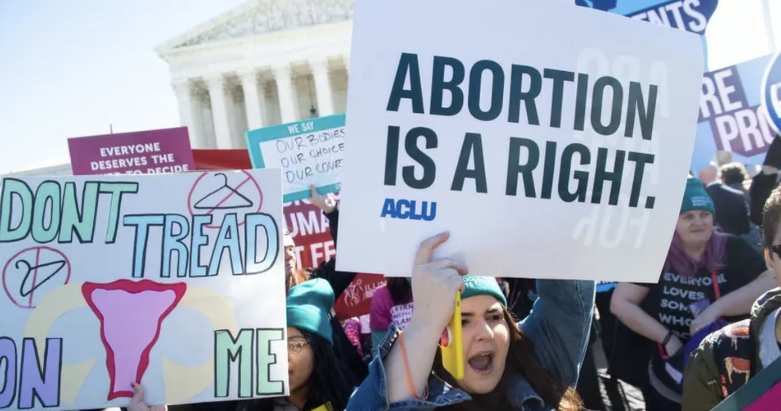
“Abortion rights activists protesting” BBC News

With that being said, here are some of the most common misconceptions about abortion, and reasons why they should be debunked!

“Most abortions take place during the third trimester!”

This is false! According to the Centers for Disease Control and Prevention (CDC), 93% of abortions (in 2020) took place during the first trimester. This is a very common misconception that is present in the media.

“Legalizing abortions will only encourage them and make the rates of abortion rise!”

This is, also, false! Data from the Guttmacher Institute suggests, “as of 2017, the rate of legal abortions sits at 13.5 per 1,000 women, the lowest rate ever recorded.” This rate has been at a slow, constant decline over the past few years.

“Most women use abortions as birth control!”

The decision to have an abortion stems from a multitude of reasons! The Guttmacher Institute conducted a survey that examined the different reasons why women would obtain abortions. The results of that survey revealed that 74% of women said they had an abortion due to being unable to care for a child or dependent because of financial reasons or because it interfered with their education. Children are a huge responsibility, and they deserve to be brought into a family that can provide for them properly.

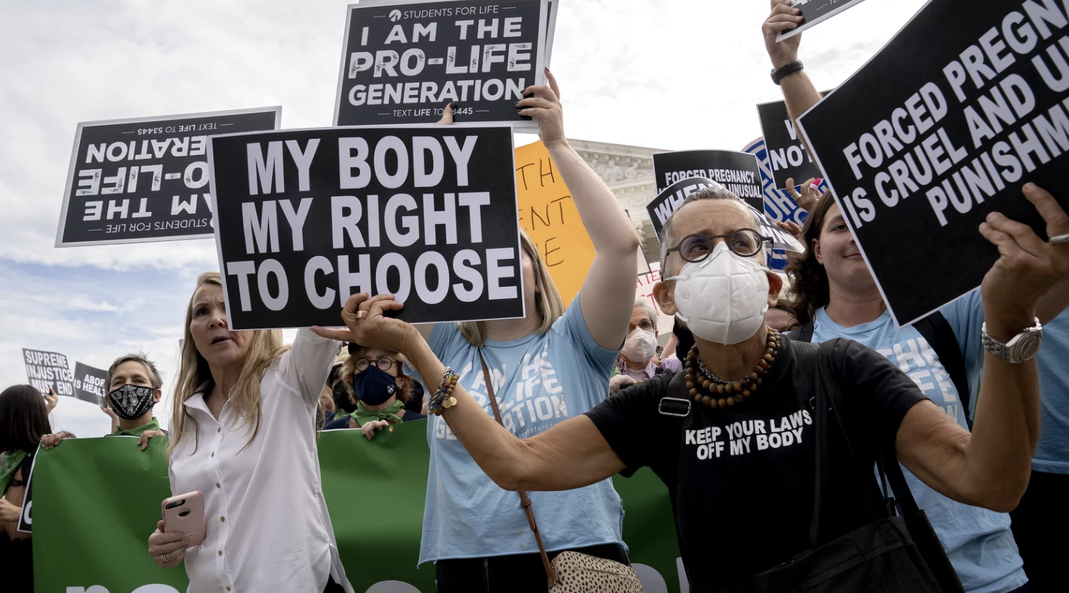
“Abortion rights activists protesting outside of the Supreme Court of the United States” NPR.

It is not your right to decide what people do with their bodies–especially women! We should be the ring leaders, the conductors, and the directors of abortion rights in this country. Let women join the conversation, and let women share their stories.

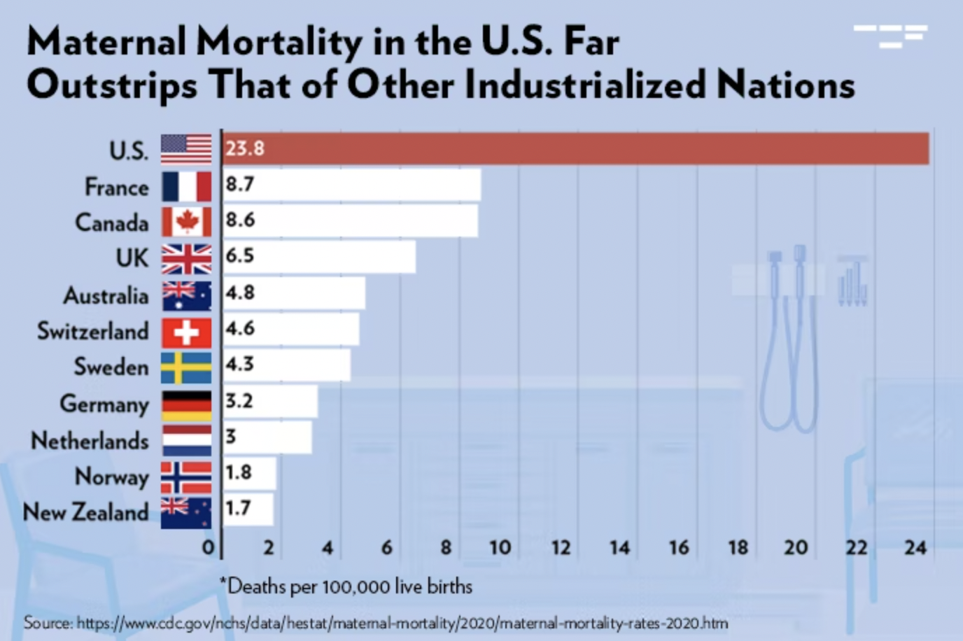
Childbirth in this country is a matter of life or death for women. The United States has one of the highest maternal mortality rates in the world. The Common Wealth Fund found that in 2020, the maternal mortality rate in the United States was three times higher than that of other highly developed countries. What does this say about our healthcare system? While childbirth is a gift and a privilege, it comes with tremendous health risks, and sadly, more often than we think, it can take the life of a woman.

We need to address the issues within our healthcare systems to make childbirth safer for women! If we are deemed, “the best country in the world,” then why is our healthcare system failing women so often and so harshly? What are you, as politicians, going to do to ensure our safety? Will you be the voice for us in our government? You have more power than we do by making legislation that supports us, and will you do so? Will you put your biases aside and act in the favor of the women of this country?

Now that we have reached this point in the letter, you might (hopefully) be asking yourself: what’s next? To protect and ensure abortion rights for women and child-bearing individuals in the United States, we need to start with education. The best way to teach people about safe sex is through sex education. According to Harvard Politics, only about 38% of high schools and 14% of middle schools in the United States teach proper sex education. It is so important that young people learn about this topic to understand the risks that can come with sex, like unplanned pregnancies. Furthermore, we need to support agencies, like Planned Parenthood, that can provide services that are vital for reproductive care. One of the most common misconceptions about Planned Parenthood is that they only conduct abortions. While they do offer this service, they also offer nearly a dozen others, including mental health counseling, cervical cancer testing and diagnosis, transgender care, and even adoption (Planned Parenthood). Having these resources readily available in communities helps to contribute to reproductive health care and education. With sex education, young people can learn more about the consequences that can arise when partaking in sexual activities, like unexpected pregnancies.
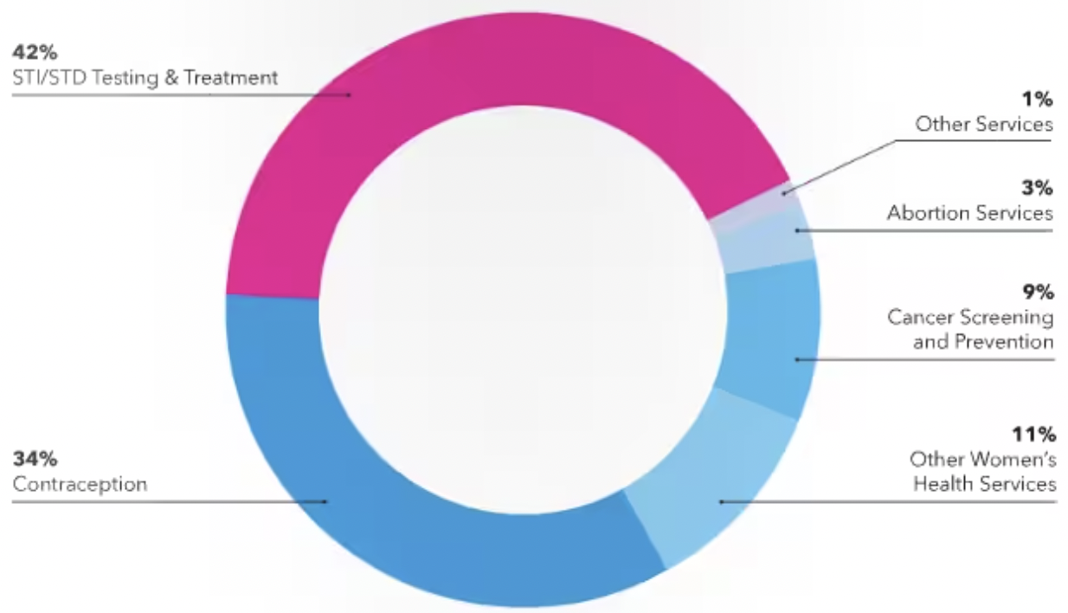

“Graph of how Planned Parenthood uses their funding” Washington Post.

While many lawmakers are moving these conversations out of schools, it is important that we must push against this. Knowledge is power, and we need to give that power to the younger generation. We see them advocating for a plethora of social justice issues, and they are not silent about their views on abortion rights.

Another extremely important step that you, as politicians, need to do is to put your biases aside. While many politicians identify as Christian, they are not representative of the rest of the United States. Fortunately, we are granted religious freedom in this country. There are religions that view abortion as a right, like Reform Judaism and the Presbyterian Church in the United States. If laws start to restrict access to abortion, what happens to those who have religious views that support it? Are they excluded from the conversation? This is why I believe there should be a CHOICE – both for those who would not get an abortion and for those who would.

As citizens, our civic duty is to vote in elections. We employ you! We choose you! If we do not like how you are representing us in government, we can easily vote you out. It is vital that American citizens vote for representatives that promise and will protect our rights to our reproductive health and choices. This generation shows up to the polls, and we will continue to do so to preserve the legacies that Roe v. Wade brought for us. Be reminded of this when you stand before Congress and make the laws of our land.
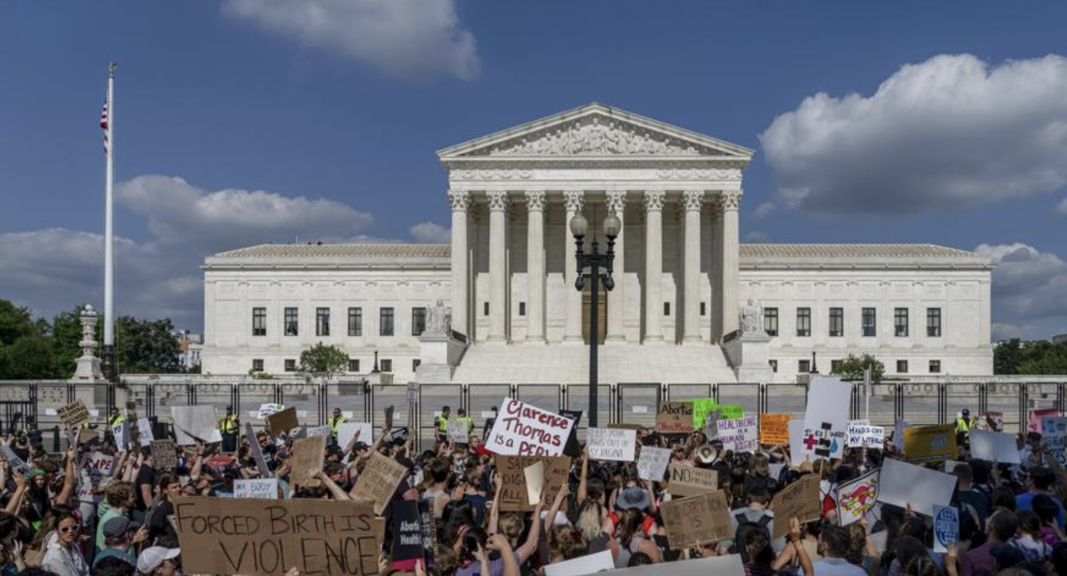

“Protestors at the Supreme Court” AP News.

Rationale:
My purpose for writing about this topic is to educate others on why reproductive rights and health care are extremely important and that they should not interfere with politics in America. In my opinion, reproductive care/abortions are a part of health care. As a woman, I do not want anyone to tell me what they think I should do with my own body, health, and life. I do not think that religious and political biases should play a role in our healthcare system because everyone has different religions and political views.
With these being my beliefs, I decided to channel them into this open letter and write about this topic. I chose United States politicians as the primary audience because they are the ones who hold the most power and are the ones who are directly making laws and decisions about abortion. A majority of our politicians in Congress are white, Christian, Conservative men who are unable to become pregnant. I believe that this is an unfair representation and that they should not be the only ones deciding abortion laws because they do not understand what pregnancy and abortions are like because they are unable to experience them. This is a women’s rights issue. Women should be at the forefront of this conversation.
The intended secondary audience is the American people. Most likely, they would be the ones who would interact with this publication. I chose to mimic a New York Times-style medium/publication because that is a very popular and widespread source of news in the United States. I often see the New York Times and consume their content, and they have a large presence in the media. Additionally, they also produce articles that discuss the topics of more left-leaning ideas, and since my open letter is about abortion rights and pro-choice ideas, I figured that styling my open letter based on the New York Times would be more appropriate than another media outlet.
Finally, the visual elements enhance my open letter because it allows the audience to understand the information more easily by laying it out in forms like graphs or photos. As a reader, I find visual elements to be helpful because I am a visual person. Being able to see something in something other than text helps me better visualize and understand the content. It also makes the letter less overwhelming and breaks up the blocks of text.

